# Lab 4.

## Fill in the blanks

1. The two possible values for a relational expression are **0** and **1**.
2. C++ uses the **&** symbol to represent the AND operator.
3. The switch statement and if statements are examples of **conditional** statements.
4. In C++ is the meaning of the OR logical operator inclusive or exclusive? **Inclusive**
5. C++ uses the **II** symbol to represent the OR operator.
6. It is good programming practice to do what to the operand after the NOT operator? **Put it in parantheses**.
7. The switch statement uses the value of a(n) **integer** expression to determine which group of statements to branch through.
8. In a switch statement the **default** branch is followed if none of the case expressions match the given switch expression.
9. C++ allows the programmer to compare the numeric values using **char**.
10. The C++ symbol for equality is **==**

## 4.1

Algorithm of the program.

// This program tests whether or not an initialized value

// is equal to a value input by the user

// Jamal Caesar

#include <iostream>

using namespace std;

int main ()

{

   float num1;

   float num2;

   cout << "Please enter an integer" << endl;

   cin >> num1;

   cout << "Enter another integer, please. " << endl;

   cin >> num2;

   cout << "num1 = " << num1 << " and num2 = " << num2 <<endl;

   if (num1 == num2)

           cout << "The values are the same." << endl << "Hey that's a coincidence!" << endl;

   else

           cout << "The values are not the same" << endl;

   return 0;

}

**Image of the program.**

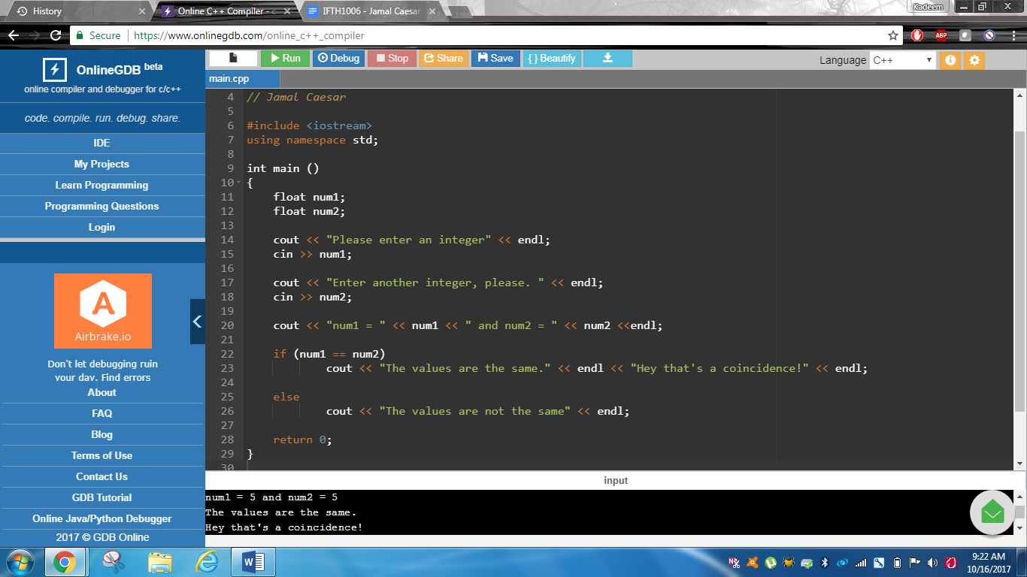

## 4.2

Image of inputting the program with 80

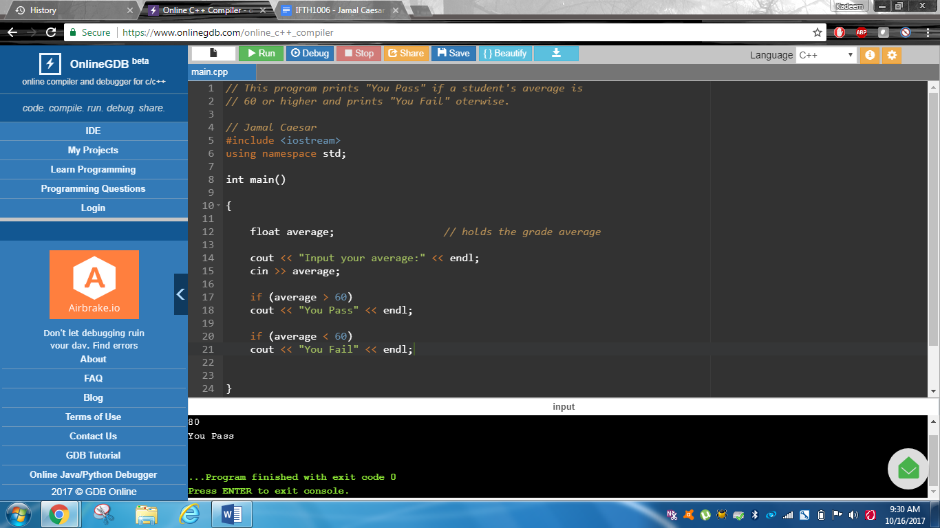

Image of inputting the program with 55

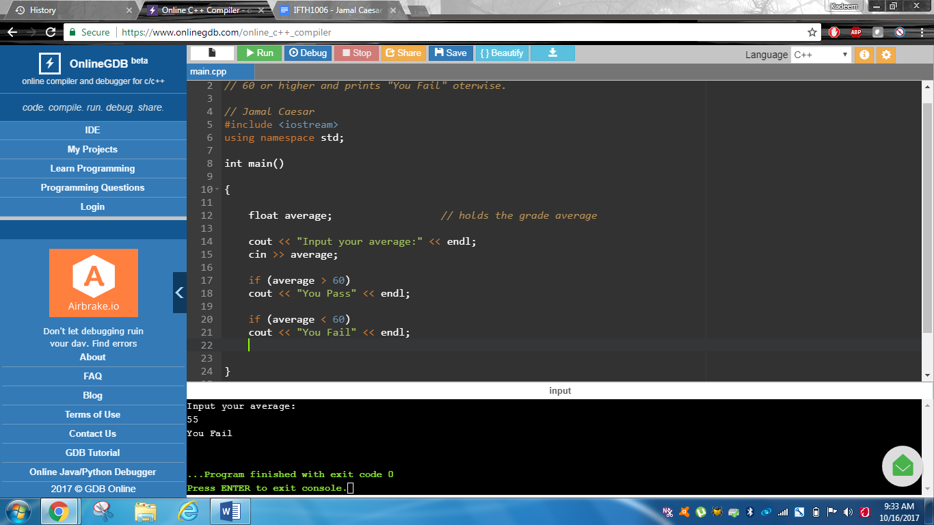

**Image of inputting the program with 60**

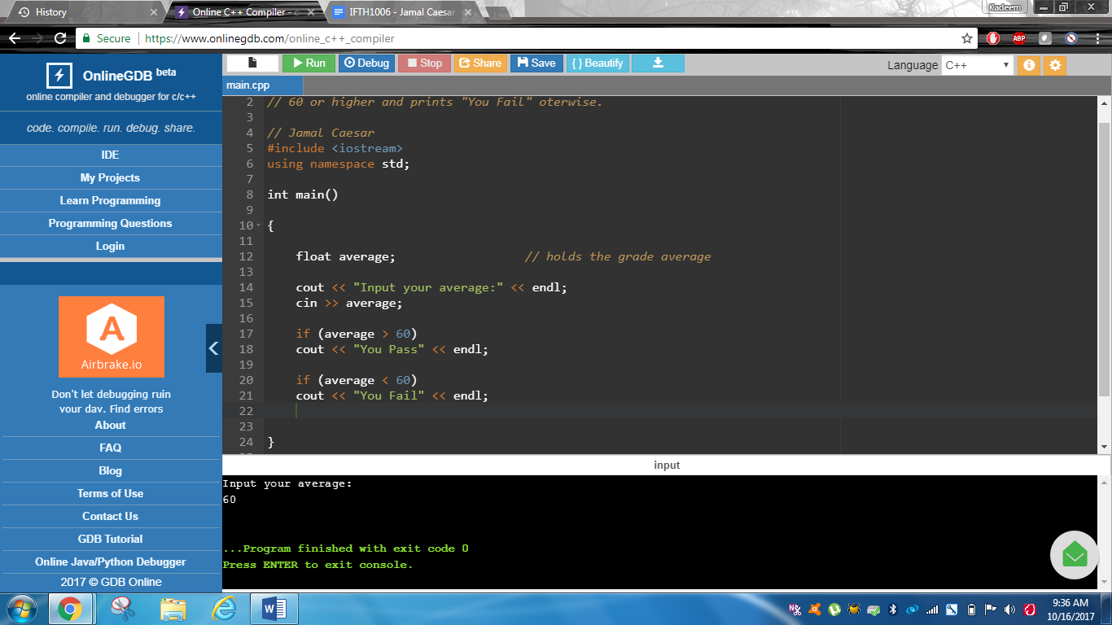

**Modified code that uses if and else instead of two if statements**

Modified code that allows categories: Invalid data (data above 100), ‘A’ category (90-100), ‘B’ category (80-89), “You pass” category (60-79), “You fail” category (0-59).

// This program prints "You Pass" if a student's average this

// 60 or higher and prints "You fail" otherwise.

// Jamal Caesar

#include <iostream>

using namespace std;

int main()

{

   float average;          // holds the grade average

   cout << "Input your average:" << endl;

   cin >> average;

   if (average >= 100){

       cout << "Invalid Data" << endl;

   }

   else if  (average >= 90){

   cout << 'A' << endl;

   }

   else if (average >= 80){

   cout << 'B' << endl;

   }

   else if (average >= 60){

   cout << "You pass" << endl;

   }

   else (average < 60);

   cout << "You fail" << endl;

   return 0;

}

What will happen to your program if you enter a negative value such as -12

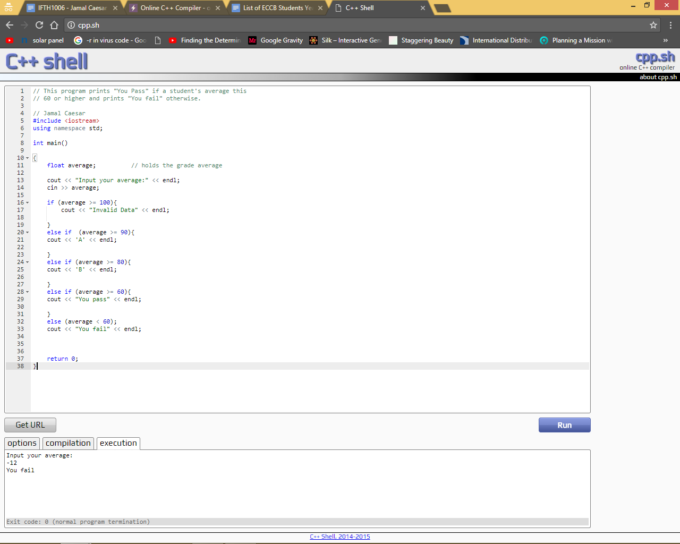

## 4.3

//This program illustrates the use of logical operators

// Jamal Caesar

#include <iostream>

using namespace std;

int main()

{

   char year;

   float gpa;

   cout << "What year student are you?" << endl;

   cout << "Enter 1 (freshman), 2 (sophmore), 3 (junior), or 4 (senior)"

        << endl << endl;

   cin >> year;

   cout << "Now enter your GPA" << endl;

   cin >> gpa;

   if (gpa >= 2.0 && year == '4')

       cout << "It is time to graduate soon" << endl;

   else if (year != '4' || gpa <2.0)

       cout << "You need more schooling" << endl;

   return 0;

}

Exercise 1

By changing the ‘>=’ to ‘!=’

Exercise 2

A user is able to do so because there can be many logical operators in a code if needed.

Exercise 3

Students with a GPA over or equal to 2.0 and/or they are in their 4th year of school are able to graduate while students with less than 2.0 in year 4 are not able to.

Exercise 4.

Yes, a programmer can replace the else.

## Lab 4.4

Code of the program.

int main ()

{

   char grade;

   string Case;

   cout << "What grade did you earn in Programming 1?" << endl;

   cin >> grade;

   switch ( grade )              // This is where the switch statement begins

   {

       case 'A': cout << "an A - Excellent work !" << endl;

           break;

       case 'B': cout << "you got a B - good job" << endl;

           break;

       case 'C': cout << "Earning a C is satisfactory" << endl;

           break;

       case 'D': cout << "While D is passing, there is a problem" << endl;

           break;

       case 'F': cout << "You failed - better luck next time" << endl;

           break;

       default: cout << "You did not enter an A, B, C, D, or F" << endl;

   }

   return 0;

}

Exercise 1

The effect on the execution of the program is that it lists everything when you place in the Grade. Therefore, the breaks are needed to not send out all the data.

Like this:

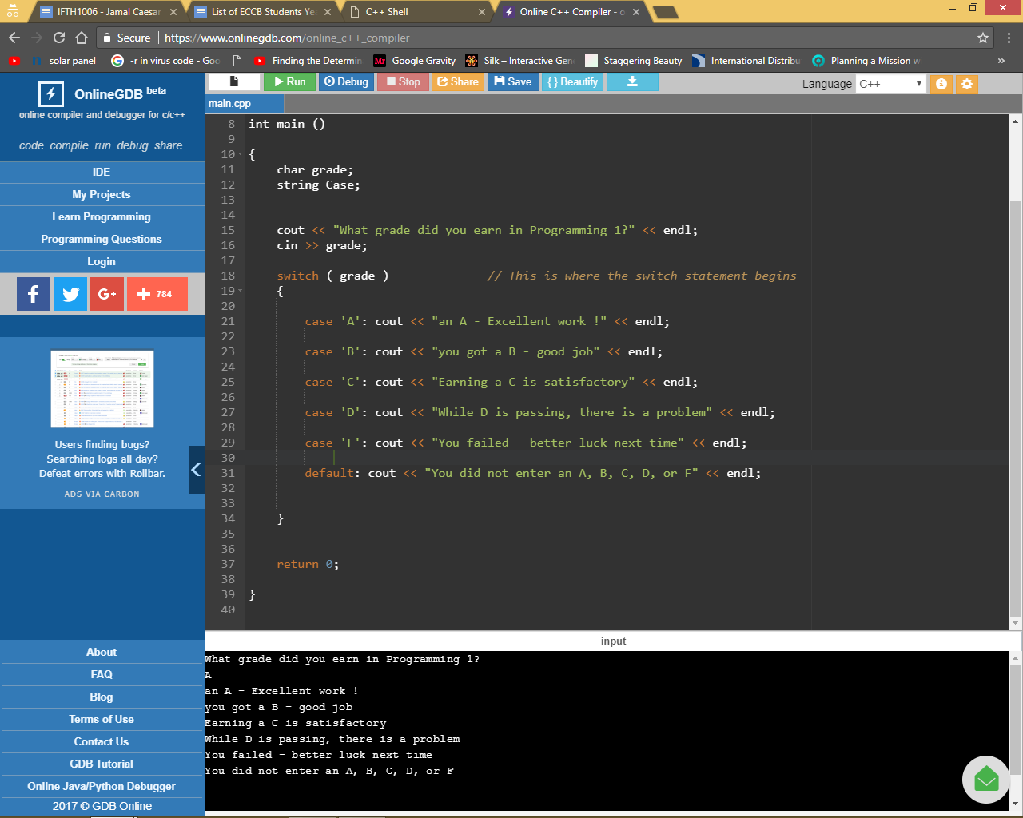

Exercise 2

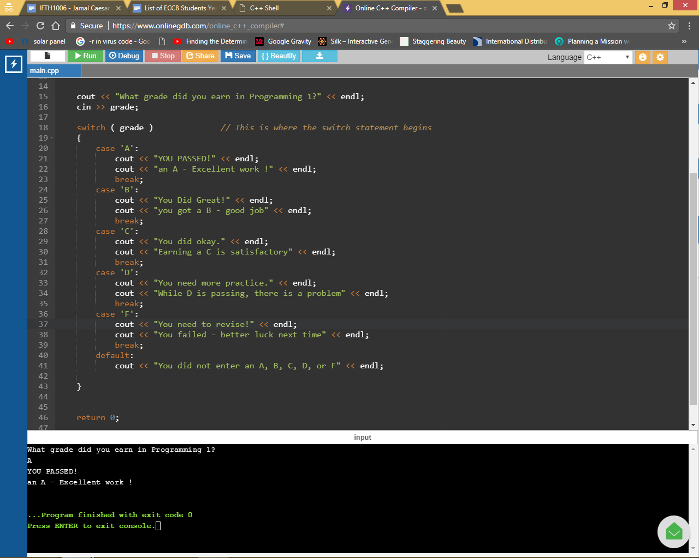

Exercise 3

The code was re-written, using a trailing if statement, after running it. It wasn’t the same as the original with the switch statement.

**// This program illustrates the use of the switch statement**

**// Jamal Caesar**

**#include <iostream>**

**using namespace std;**

**int main ()**

**{**

**char grade;**

**string Case;**

**cout << "What grade did you earn in Programming 1?" << endl;**

**cin >> grade;**

**switch ( grade )              // This is where the switch statement begins**

**{**

**if ( 'A'){**

**cout << "YOU PASSED!" << endl;**

**cout << "an A - Excellent work !" << endl;**

**break;**

**}**

**else if ('B'){**

**cout << "You Did Great!" << endl;**

**cout << "you got a B - good job" << endl;**

**break;**

**}**

**else if ('C'){**

**cout << "You did okay." << endl;**

**cout << "Earning a C is satisfactory" << endl;**

**break;**

**}**

**else if ('D'){**

**cout << "You need more practice." << endl;**

**cout << "While D is passing, there is a problem" << endl;**

**break;**

**}**

**else if ('F'){**

**cout << "You need to revise!" << endl;**

**cout << "You failed - better luck next time" << endl;**

**break;**

**}**

**else**

**cout << "You did not enter an A, B, C, D, or F" << endl;**

**}**

**return 0;**

**}**

## Lab 4.5

A program had to be made to calculate the quarterly bill for water usage in a building.

Below would be the algorithm used to work the program out.

**// This program will demonstrate how to calculate the quarterly bill for water**

**#include <iostream>**

**#include <cmath>**

**#include <iomanip>**

**using namespace std;**

**int main ()**

**{**

**float bill1;                             // Will accept the water bill for quarter 1**

**float bill2;                              // Will accept the water bill for quarter 2**

**float bill3;                             // Will accept the water bill for quarter 3**

**float bill4;                            // Will accept the water bill for quarter 4**

**float average;                          // Will calculate the average for the bills**

**float total;                             // Will calculate the total of bills placed together.**

**cout << setprecision(2) << fixed << showpoint;**

**cout <<"Please input your water bill for quarter 1" << endl;**

**cin >> bill1;**

**cout << "Please input your water bill for quarter 2" << endl;**

**cin >> bill2;**

**cout << "Please input your water bill for quarter 3" << endl;**

**cin >> bill3;**

**cout << "Please input your water bill for quarter 4" << endl;**

**cin >> bill4;**

**total = bill1 * 0.25 + bill2 * 0.25 + bill3 * 0.25  + bill4 * 0.25;**

**average = total / 4;**

**if (average >75.00){**

**cout << " Your average monthly bill is $" << average << " You are using excessive amounts of water" << endl;**

**}**

**else if (average >=25.00){**

**cout << " Your average monthly bill is $" << average << " You are using the typical amount of water." << endl;**

**}**

**else if (average <25.00){**

**cout << " Your average monthly bill is $" << average << " You are conserving lots of water, good job!" << endl;**

**}**

**else**

**cout << " Your cost cannot be calculated" << endl;**

**return 0;**

**}**

Example of the program running. 1/2

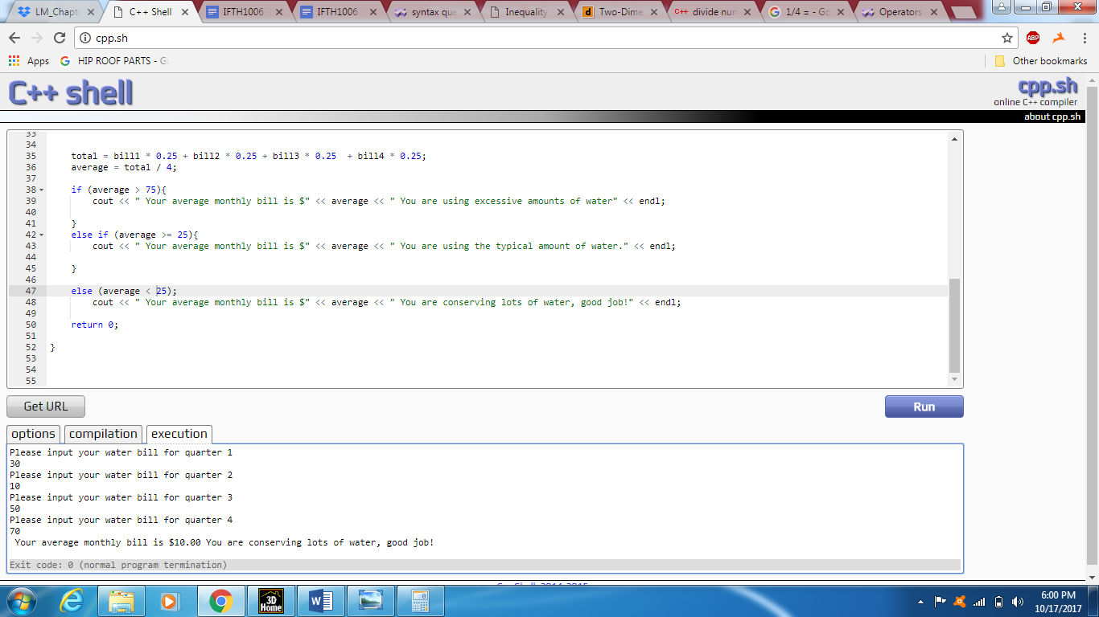

Example of the program running. 2/2

